# Digital Logic Design (Lab 2)

# Experiment 2: Basic gates implementation using universal Gates

**______________________________________________________________________________**

**Name:** Faraz Ahmad **Registration No:** 2020-CS-144

**Date:** 16th March 2021 **Grade and Signature: ………………………**

|  |  |  |  |  |
| --- | --- | --- | --- | --- |
| **CLO1** | Recognize various logic gates | | | |
| **Psychomotor/Affective** | **Level1** | **Level2** | **Level3** | **Level4** |
|  |  |  |  |
| **Report Marks (2)** |  | | **Total marks (10)** |  |

**Objectives:** To get understanding of basic logic gates and function of universal gates.

**THEORY:** All Logic gates can be implemented using universal gates which are NAND and NOR.

**AND, OR** and **NOT** are called basic gates as their logical operation cannot be simplified further.

**NAND and NOR** are called universal gates as using only NAND or only NOR any logic function can be implemented. Using NAND and NOR gates and **De Morgan’s Theorems** different basic gates & EX-OR & EX-NOR gates are realized.

**Equipment required:**

Power Supply, Breadboard, Connecting wires, ICs 7400, 7402.

1. **AND Gate ( A . B )**

**Circuit Diagrams**

**Using NAND Using NOR**

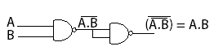 

**Truth Table**

|  |  |  |
| --- | --- | --- |
| **Input A** | **Input B** | **Output Y** |
| **0** | **0** | **0** |
| **0** | **1** | **0** |
| **1** | **0** | **0** |
| **1** | **1** | **1** |

**Procedure:**

1. **Draw** the circuits with formulas at each step to show the implementation of all given gates.
2. **Simulate** your working in Multisim software.
3. **Implement** the circuit and record the input in truth table
4. Repeat the procedure for all given gates.
5. **OR Gate ( ……………….)**

**Circuit Diagrams**

**Using NAND Using NOR**

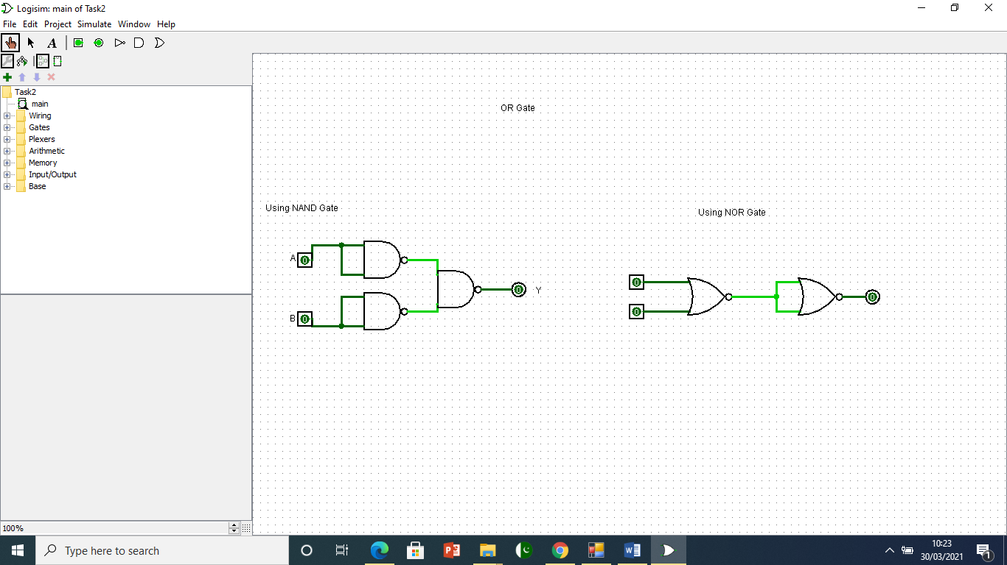

**Truth Table**

|  |  |  |
| --- | --- | --- |
| **Input A** | **Input B** | **Output Y** |
| **0** | **0** | **0** |
| **0** | **1** | **1** |
| **1** | **0** | **1** |
| **1** | **1** | **1** |

1. **NOT Gate (…….)**

**Circuit Diagrams**

**Using NAND Using NOR**

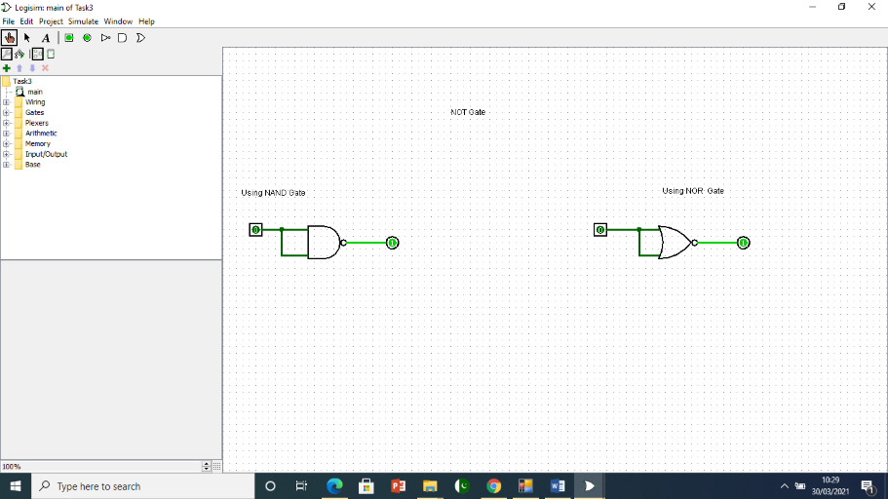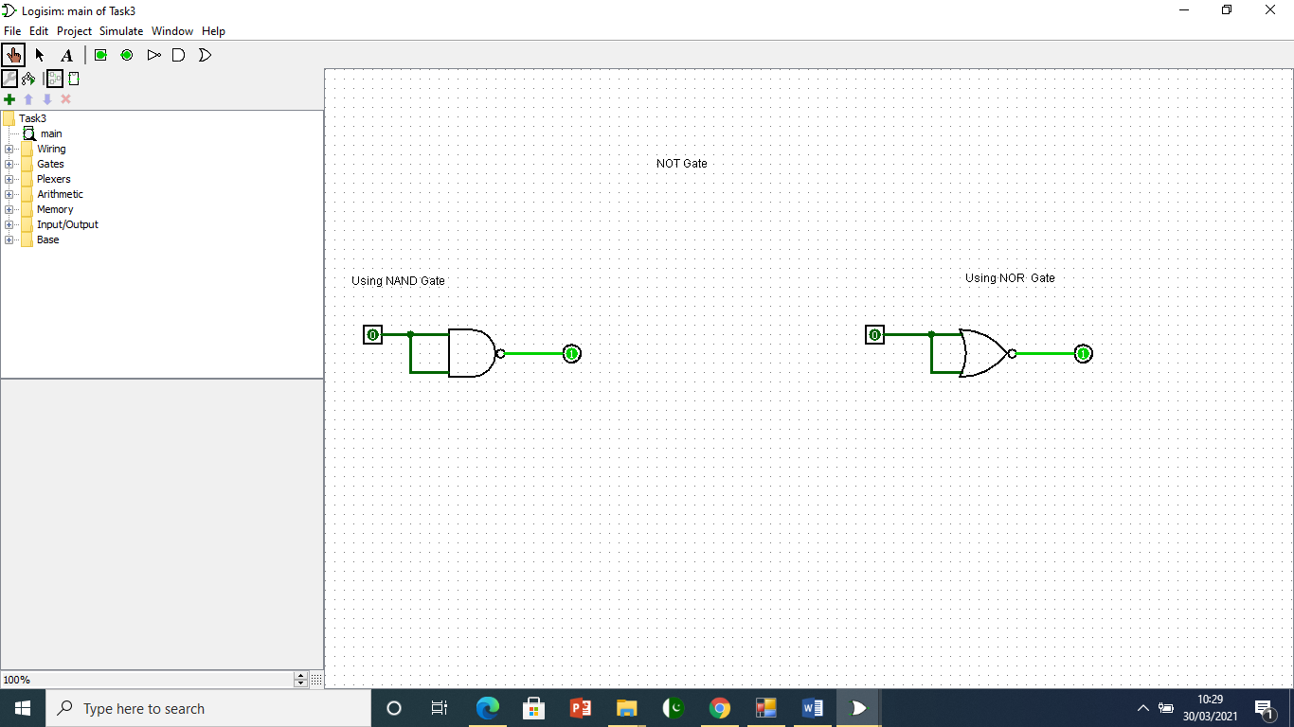

**Truth Table**

|  |  |
| --- | --- |
| **Input A** | **Output Y** |
| **0** | **1** |
| **1** | **0** |

1. **EX-OR Gate (………………….)**

**Circuit Diagrams**

**Using NAND Using NOR**

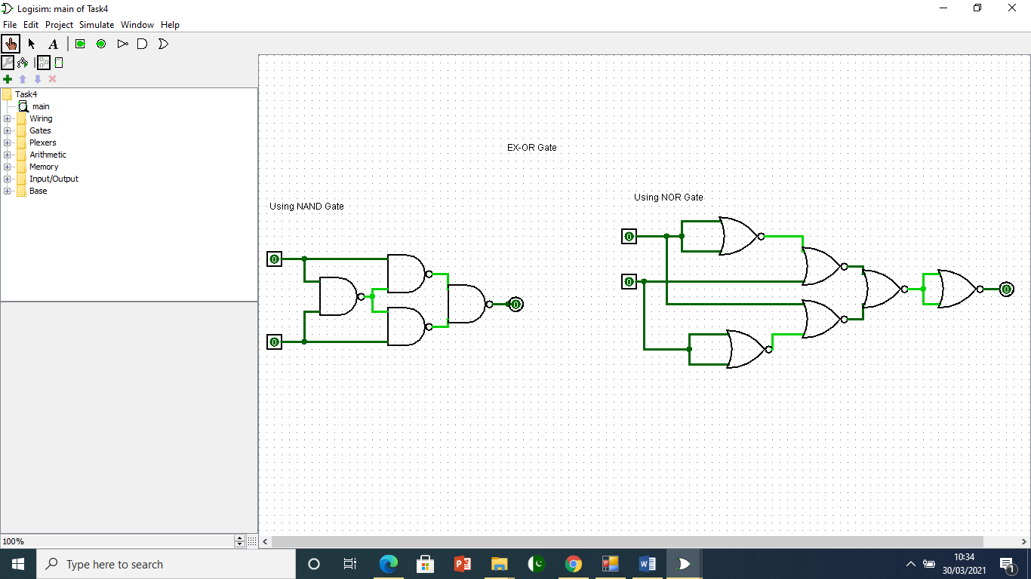

**Truth Table**

|  |  |  |
| --- | --- | --- |
| **Input A** | **Input B** | **Output Y** |
| **0** | **0** | **0** |
| **0** | **1** | **1** |
| **1** | **0** | **1** |
| **1** | **1** | **0** |

1. **EX-NOR Gate (…………………...)**

**Circuit Diagrams**

**Using NAND Using NOR**

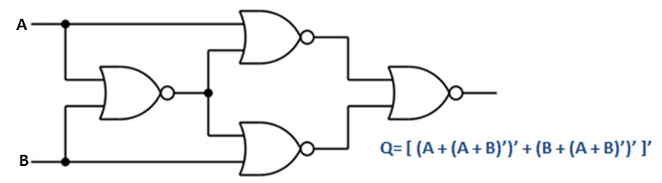 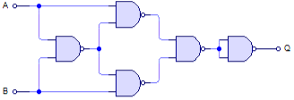

**Truth Table**

|  |  |  |
| --- | --- | --- |
| **Input A** | **Input B** | **Output Y** |
| **0** | **0** | **1** |
| **0** | **1** | **0** |
| **1** | **0** | **0** |
| **1** | **1** | **1** |

1. **NOR using NAND and NAND using NOR Gates**

**Circuit Diagrams**

**NOR Using NAND NAND Using NOR**

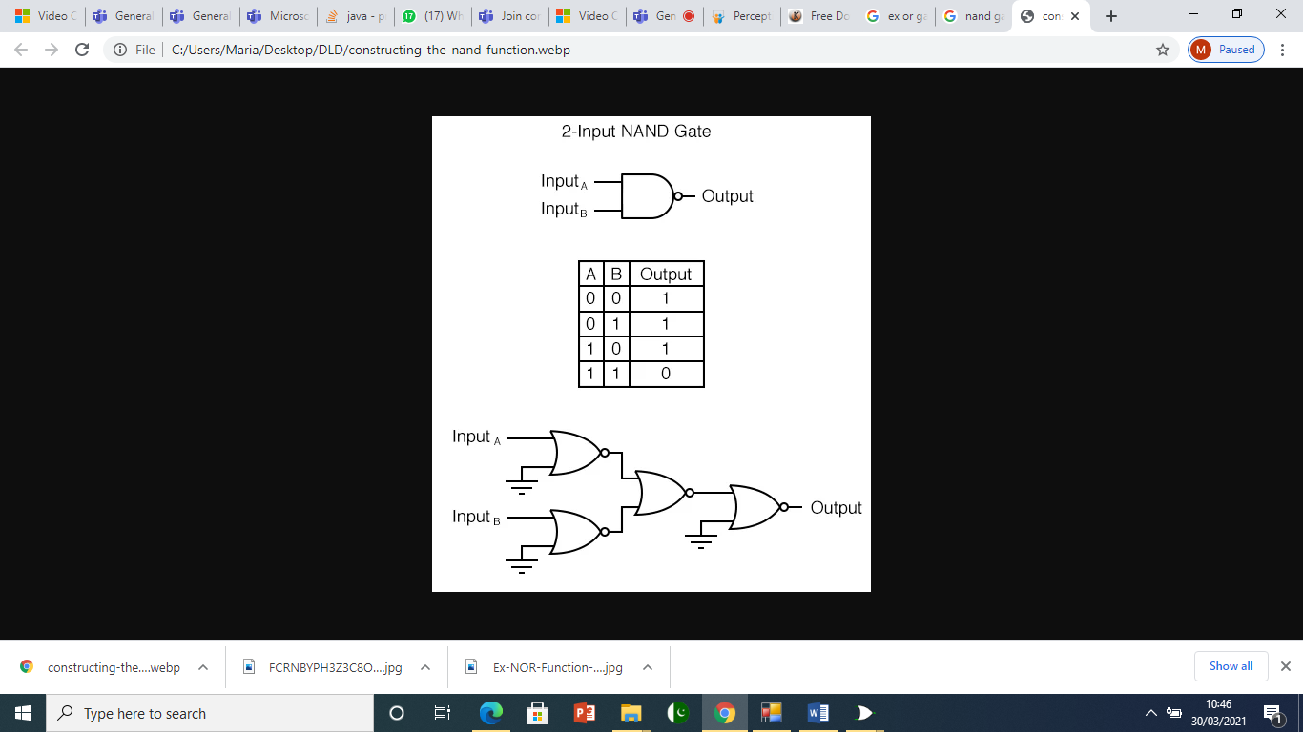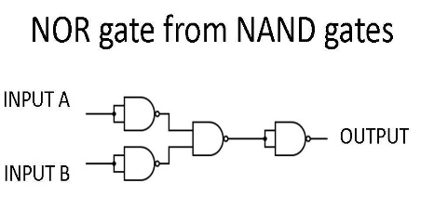

**Truth Table Truth Table**

|  |  |  |  |  |  |  |
| --- | --- | --- | --- | --- | --- | --- |
| **Input A** | **Input B** | **Output Y** |  | **Input A** | **Input B** | **Output Y** |
| **0** | **0** | **1** | **0** | **0** | **1** |
| **0** | **1** | **0** | **0** | **1** | **1** |
| **1** | **0** | **0** | **1** | **0** | **1** |
| **1** | **1** | **0** | **1** | **1** | **0** |

1. **Conclusion: Write what you learnt in your own words.**

Digital electronics relies on the actions of just seven types of logic gates, called AND, OR, NAND (Not AND), NOR (Not OR), XOR (Exclusive OR) XNOR (Exclusive NOR) and NOT. The actions of any of these gates can also be described using Boolean statements. There is a one-to-one relationship between logic gates and Boolean expressions and how logic gates are combined to create full systems.